Gyroscopic and Pressure Instruments
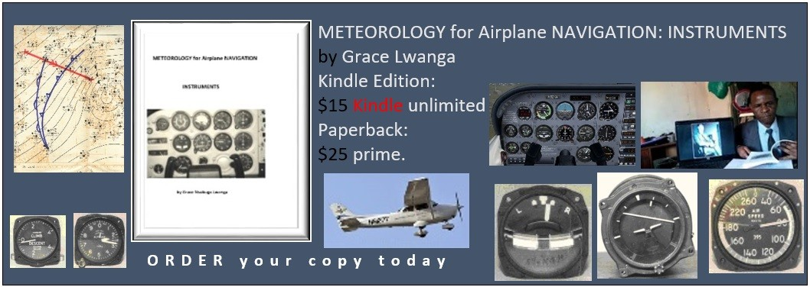
Thanks to Professor James, R. Holton who in 1972 wrote a book called “An Introduction to Dynamic Meteorology” (Academic Press, Inc., 111 Fifth Avenue, New York, N.Y. 10003). In his book he described atmospheric motion as being composed of linear and non- linear parts. Based on this fact, Grace Lwanga wrote the book “METEOROLOGY for Airplane NAVIGATION (INSTRUMENTS)”.
This book describes Airplane NAVIGATION INSTRUMENTS as being composed of Gyroscopic and Pressure Instruments parts. From page 17 to 21, the book clearly accounts for all the errors found in the instruments. Gyroscopic and Pressure Instruments are known as the Dead Reckon (DR) instruments.
This book can be found on:
https://www.amazon.com/Mr.-Grace-Nsubuga-Lwanga/e/B07KDJ91W2

