Navigation
Navigation may be defined as the free movement of a vehicle, from one station to another, for the fulfillment of a purpose. Such a movement may be carried out on the sea, land or in the air; aided or unaided by external navigational equipment; and finished off in the most economical, punctual and safe plan.

In aviation, when a vehicle is navigated without the aid of external navigational facilities (such as a radar or landmarks) the navigation is called Dead Reckoning (DR) navigation.

DR navigation is a remarkable success for Man, because he has no flying instinct. For example, the birds cannot fly without depending on the outside visual contact; although they possess an instinct and a very long flying experience.

The DR navigation instruments are: gyroscopic instruments and pressure instruments.
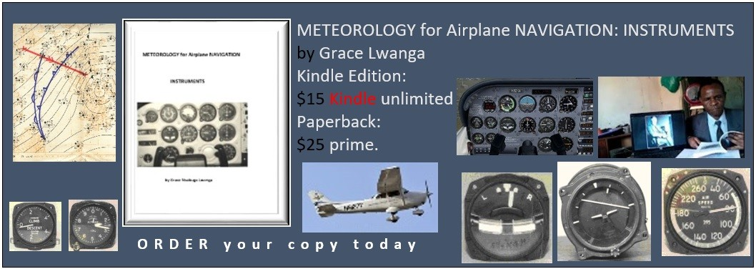

The above excerpt is taken from page 11 of the book called “METEOROLOGY for Airplane NAVIGATION (INSTRUMENTS” available in eBook and paper back at:
https://www.amazon.com/Mr.-Grace-Nsubuga-Lwanga/e/B07KDJ91W2
Thank you for your time.

