The navigation computer

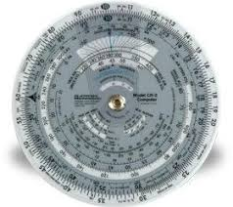
Fig. 1.1. Side “B” of the navigation computer.
The photograph shows the B- side of the navigation computer. The B- side can be used for computing the True Air Speed; Rectified Air Speed; Mach Number; Density Altitude; True Altitude; time gone; fuel and distance conversions; multiplication and division.
(Courtesy of Soroti Flying School, Uganda).
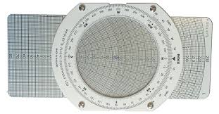
Fig. 1.2. Side “A” of the navigation computer.
The photograph shows the A-side of a navigation computer. The A- side can be used for finding the True heading; Track; ground speed and the wind. The letter L (shown at the top right hand corner of the wind arm) stands for all air speeds, which are below 300 knots True Air Speed. The flip side shows the letter H, which denotes the air speeds above 300 knots True Air Speed.
(Courtesy of Soroti Flying School, Uganda).

The above excerpt is taken from page 16 and 19 of the book called “METEOROLOGY for Airplane NAVIGATION (INSTRUMENTS” available in eBook and paper back at:
https://www.amazon.com/Mr.-Grace-Nsubuga-Lwanga/e/B07KDJ91W2

