Heat Wave
Welcome to the topic of Heat Waves. The topic was first introduced by the SCIENCE IN ACTION podcast of BBC World Service Radio, 10-August-17.
Our aim is to change the Podcast file into a Blogpost file so that the literally world can also gain from the podcast. The original content of the podcast remains almost the same.
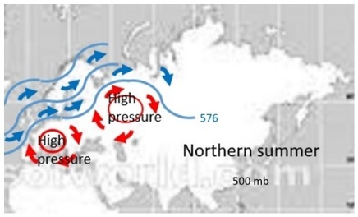
In the summer of 2003, at least 35,000 people died in western Europe as a result of the heatwave. It was the warmest for up to 500 years. Temperatures reached 32.2 °C.

In April and May 2016, India experienced a major heat wave. A national record high temperature of 51.0 °C was set in the town of Phalodi.

In February, 2009 heat waves also affected Australia, claiming 173 lives in Victoria.
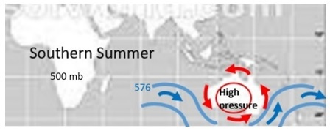
Heat waves occur in the sub-tropical landmasses during summer. Their physical feature is a large surface anticyclone. The contours of the anticyclone are in the shape of troughs-and-ridges (i.e. a wave form). The stable air mass subsidence within the anticyclone tends to cause a dry adiabatic-rate heating and extreme temperatures to occur in the surface area. Hence the term ‘heat wave’.

Unlike Cyclones, Anticyclones tend to move very slowly (causing droughts; bush fires; poor visibility; bronchitis inflammation; dehydration; and air pollution). Not all heat waves are a natural disaster. Deadly heat waves occur very rarely.

To make a comment on this Heat Waves Document, please contact the author gnlwanga@gmail.com.

Thank you for sharing your time with us.

