Air France Flight 447
Welcome.
On 1 June 2009, Airbus A330 of Air France took off and immediately crashed into the Atlantic Ocean at night, killing all 228 passengers, aircrew and cabin crew aboard the aircraft. It was on a scheduled flight from Rio de Janeiro, Brazil to Paris, France.
The investigation report showed that the aircraft crashed after the Air Speed Indicator reading error – likely due to the aircraft's pitot tubes being obstructed by ice crystals. The pilot got confused and ultimately caused the aircraft to ditch into the sea.
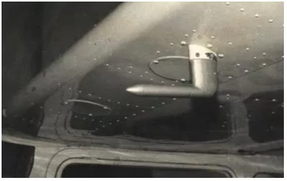
Many reports on this accident have been given by aviation experts. It is a great pity that so many innocent lives were lost.
A new approach to this problem uses the theory of aircraft Dead Reckon (DR) pressure instruments. The AIR SPEED INDICATOR (ASI) theory is described in great detail. Four C.P.L. and one A.T.P.L. problem solutions have been included, also.
The above excerpt is taken from page 173 to 185 of the book called “METEOROLOGY for Airplane NAVIGATION (INSTRUMENTS” available in eBook and paper back at:
https://www.amazon.com/Mr.-Grace-Nsubuga-Lwanga/e/B07KDJ91W2

